|  |
| --- |
| KP GAMES |
| Survival of the fittest |
| Basic 3-D Game |
| Version #1.0  All work Copyright © 2016 by KP Games.  All rights reserved. |
| **KHILAN PATEL - 300785048** |
|  |

|  |
| --- |
| March 25th 2016 |

Table of Contents

Update History 3

Game Overview 4

Game Play Mechanics 4

Camera 4

Controls 4

Interface Sketch 4

Menu and Screen Descriptions 5

Game World 6

Levels 6

Enemies 6

Items 6

Sound Index 6

Scoring 6

Multimedia index 7

Future Features 7

# Update History

Github link: <https://github.com/Khilan/3D-Game>

|  |  |  |
| --- | --- | --- |
| Commits | Description | Dates |
| Update 0.01 | Initial Commit | (Mar 11, 2016) |
| Update 0.1 | Created Mesh and Game Environment | (Mar 18, 2016) |
| Update 0.2 | Made the Game Mechanics work | (Mar 25, 2016) |
| Update 1.0 | Final Commit | (Mar 25, 2016) |

1. **Game Overview**

*This game is about the Survival area where the fittest player can survive. Player has to collect the coins in order to get to complete the mission. There are enemies and hurdle in the survival area, player has to avoid those hurdles and find out the way in order to survive and complete mission.*

1. **Game Play Mechanics**

*Player will get 10 points for 1 coin. If player hit with hurdles or hit with enemies then the lives will reduce. When player losses all lives, game will over and player will be asked to restart the game.*

1. **Camera**

It’s a first person view game.

1. **Controls**

*Player can use WASD or standard arrow keys to move and space bar to jump.*

1. **Interface Sketch**

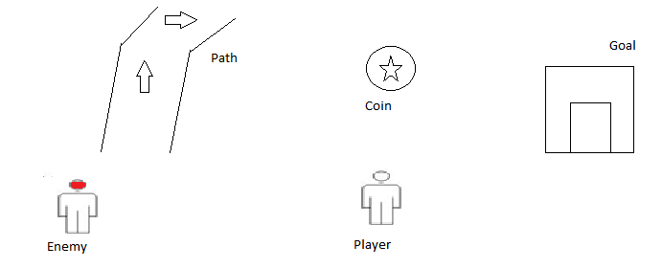

1. **Menu and Screen Description**

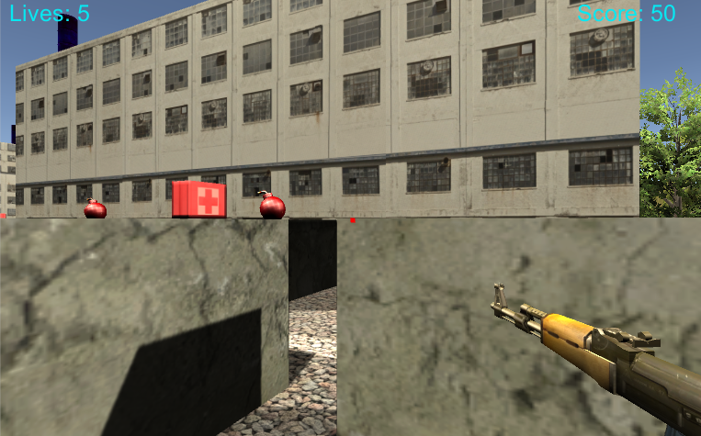

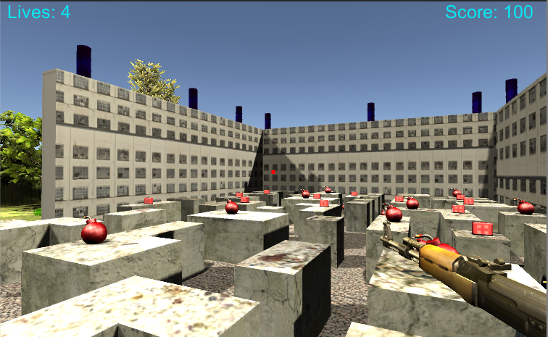

Player have 5 lives to survive and once he get the medical kit then player will get points.

1. **Game World**

*Game world is about the survival area with some hurdles.*

1. **Levels**

The game doesn’t have any levels but it has checkpoints, so when player die at a certain point he might continue from same or nearby point if he has crossed the checkpoint.

1. **Enemies**

*There is enemy like hurdles which cause damage when player collides or hit with them.*

1. **Items**

|  |  |
| --- | --- |
| **Bomb** |  |

These items cause damage life of player.

1. **Sound Index**
2. Player Walking Sound
3. Shooting Sound
4. Gameover Sound
5. Finish Sound
6. **Scoring**

*Scoring will update when player will get coins and reaches checkpoints.*

1. **Multimedia index**

|  |  |
| --- | --- |
| Gun |  |
| Medical kit |  |
| Barrel |  |

1. **Future Features**

It may include

1. Power ups for Player
2. Enemies
3. Levels